EF Notes

Navigation property:

just a code property showing table associations/relationships.

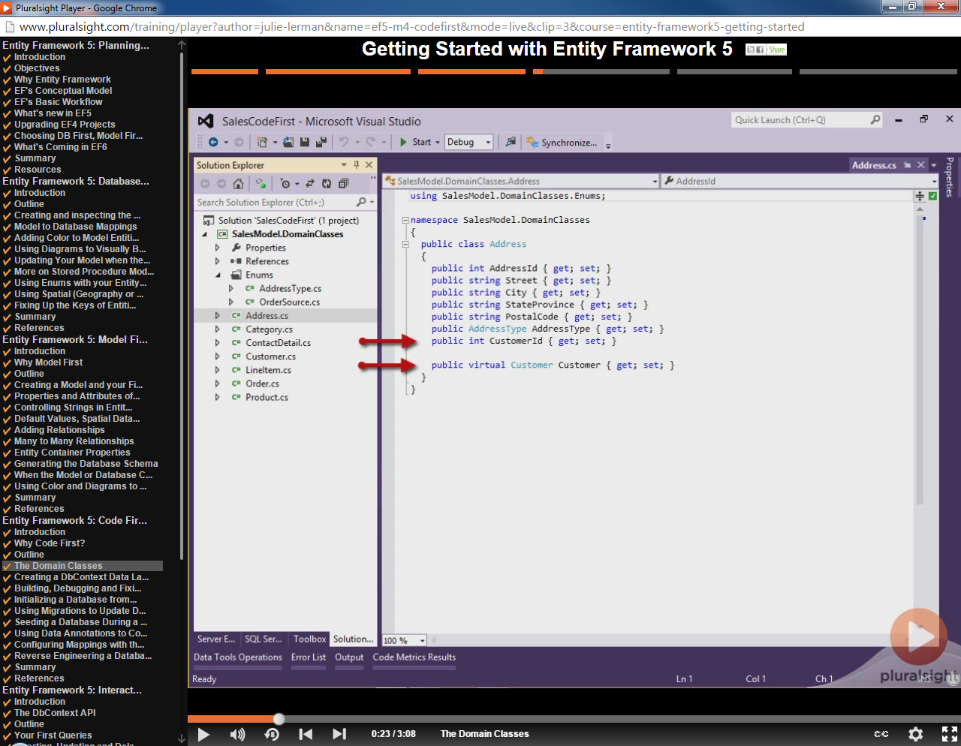

Best practice is to include foreign key property as well as related navigation property.

AddressId is primary key.

CustomerId is foreign key.

Customer is navigation property to related customer (in this case one-to-one relationship).

For one-to-many relationships, use property of type ICollection of <Entity>

If you want relationship properties (navigation collections of outside entity) to be populated via Lazy Loading, declare as virtual.

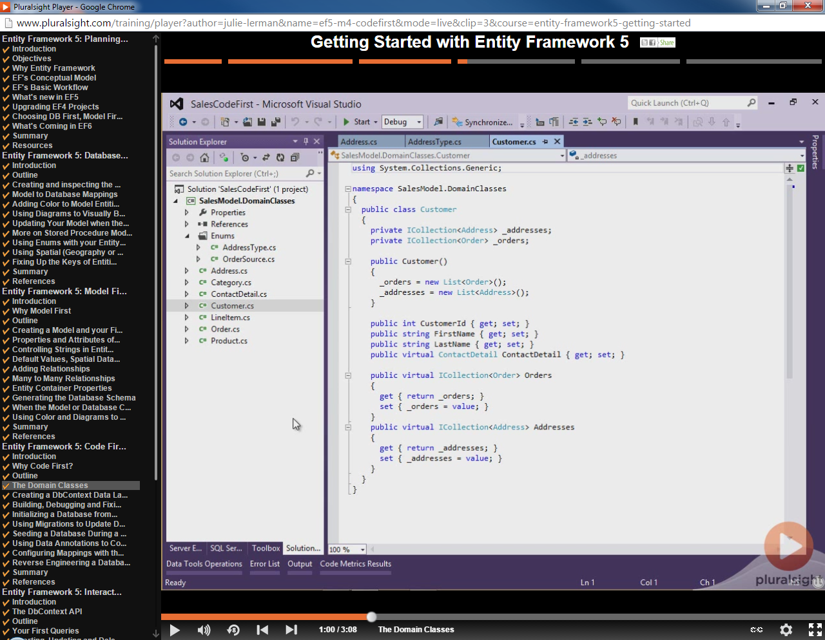

Lazy Loading

‘New’ the collections in Entity constructor

Data Layer (Context):

Provides interactions between the database.

Uses the db objects created previously – could be in separate dll or same.

Classes inherit from System.Data.Entity.DbContext.

Should contain entities of type DbSet, which represent the entities in the database that will be inserted,updated, deleted…

Allows querying of individual entities in the database. If you don’t necessarily need to query the entity or the entity is queried as a child of another entity, don’t need the DbSet.

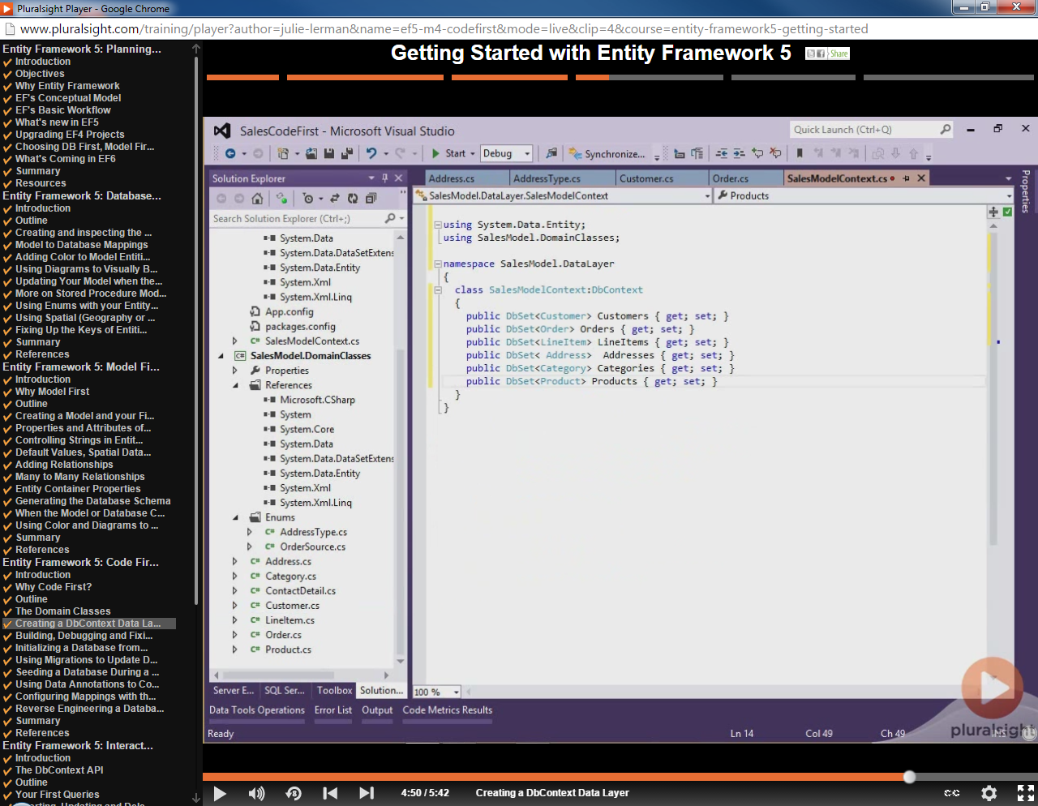

Configuration:

Where is the database?

Connection string – usually with your data layer, in app.config?

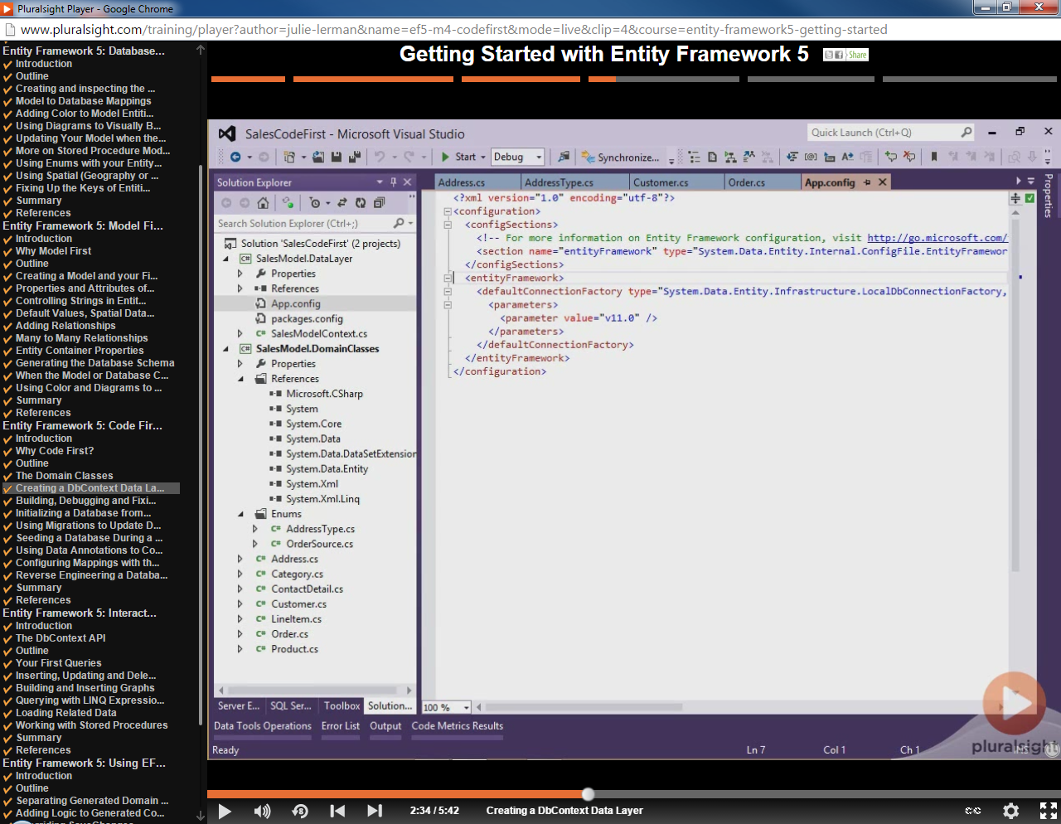

FluentAPI Versus Annotations –

Probably best to use FluentAPI to do configurations instead of Annotations. FluentAPI can also do table mappings.

Using FluentAPI

Introduce configurations based on FluentAPI in your data layer (class which derives from DbContext).

Override OnModelCreating function. At this point, data layer has read the related entity classes and is ready to apply configurations to them, through passed in DbModelBuilder.

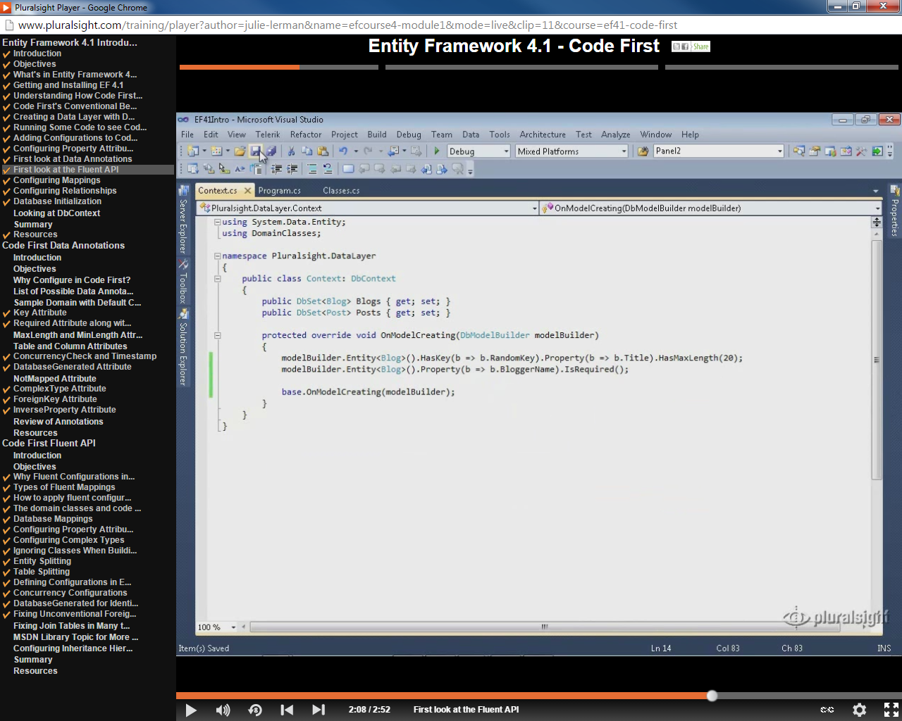

Using EntityConfiguration classes

Derive from EntityTypeConfiguration<Entity>.

Add the classes to the DbModelBuilder in the data layer class’ OnModelCreating.

Put configuration code for the entity in the constructor of the configuration class.

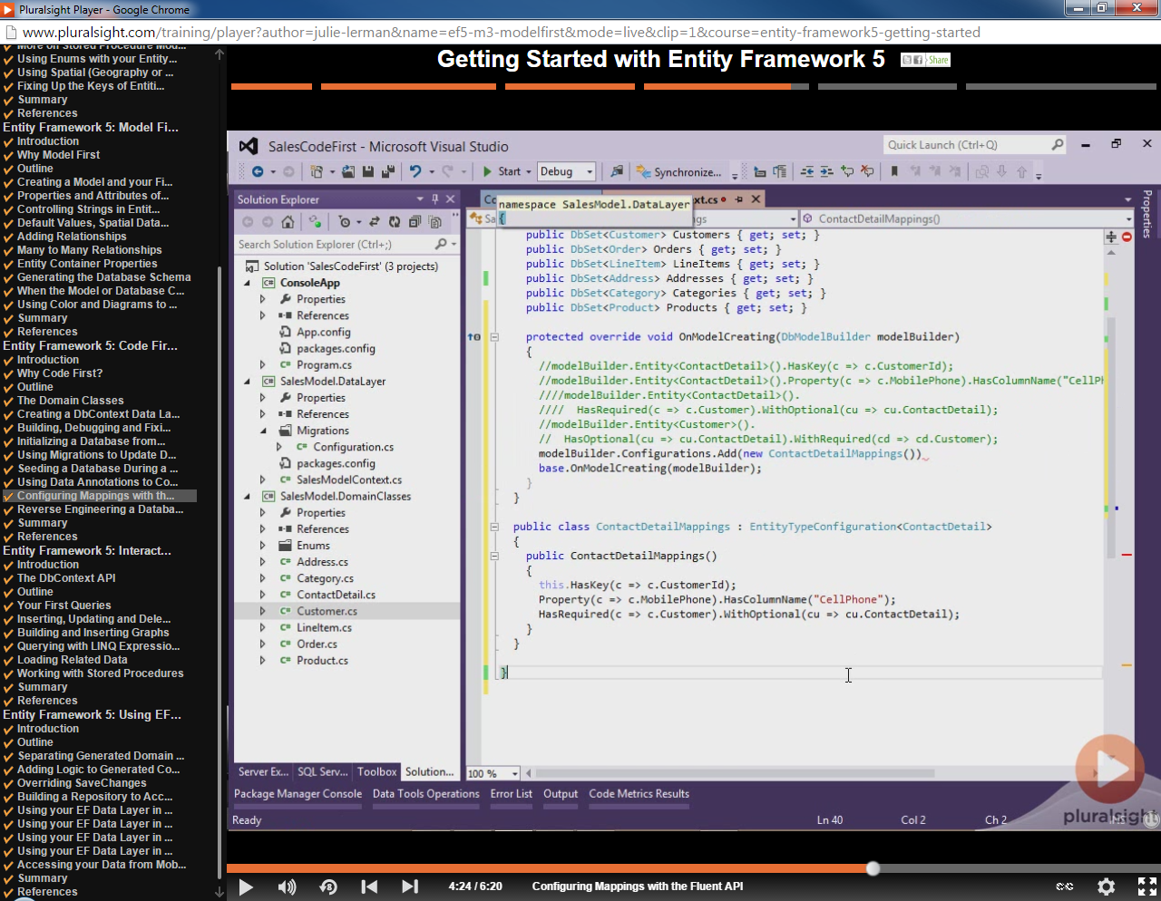

Mappings

Mappings indicate relationship between database entity and the entity object. Can include mapping of the entity object property name to the database entity field name, table name to entity name etc…

[Table("ActualTableName")]

public class DBEntity

{

[Column("TableKeyName")]

[Key]

public int SomeKeyColumn { get; set; }

[MaxLength(50)]

public string SomeTextColumn { get; set; }

[Required]

public bool SomeRequiredColumn { get; set; }

[Timestamp]

public byte[] RowVersion { get; set; }

[Key,ForeignKey("RelatedEntity")]

public int RelatedId { get; set; }

public virtual RelatedDBEntity RelatedEntity { get; set; }

}

public class RelatedDBEntity

{

public int RelatedId { get; set; }

}

Keys

Default in Code First is to look for entity key by naming convention (either ID or typeName + id). To overcome this, can use annotations [Key] or fluentAPI.

Default foreign key in Code First – overcome by annotation [ForeignKey(“property name”)]

“property name” indicates the property within the current entity that the key is a foreign key to. In this case, the CustomerId property is a foreign key to the Customer property.

Foreign key property

[Table("ActualTableName")]

public class DBEntity

{

[Column("TableKeyName")]

[Key]

public int SomeKeyColumn { get; set; }

[Key,ForeignKey("RelatedEntity")]

public int RelatedId { get; set; }

public virtual RelatedDBEntity RelatedEntity { get; set; }

}

public class RelatedDBEntity

RelatedId is a foreign key to the RelatedEntity property.

{

public int RelatedId { get; set; }

}

Concurrency:

Row concurrency in a table is typically done by a RowVersion type of field (SQL Server calls it a Timestamp). When correctly indicated, EF will automatically check for row concurrency before UPDATES and DELETES and will raise an error if the row has changed. This will create a field in the database table of type Timestamp.

In the model, related property must be of byte array (byte[]).

public byte[] RowVersion { get; set; }

In the model, related property must be of byte array (byte[]).

Annotation:

public class DBEntity

{ [Timestamp]

public byte[] RowVersion { get; set; }

}

FluentAPI:

Property(a=> a.RowVersion).IsRowVersion();

Not Mapped:

Ignored by model builder.

Annotation:

public class DBEntity

{

[NotMapped]

public decimal NonMappedProperty { get; set; }

}

Computed Columns/Database Generated Columns:

EF assumes that all entity key fields are Identity generated. This might not be the case. You could have key fields where uniqueness is generated by a formula in the database.

Columns such as something that has a default that includes a function, ie getdate().

Computed column – column where data is generated from combination of other columns.

Entity

Read Only Code First Modeling:

If you want a visual modeling tool (read-only) for Code First, download Entity Framework Power Tools.

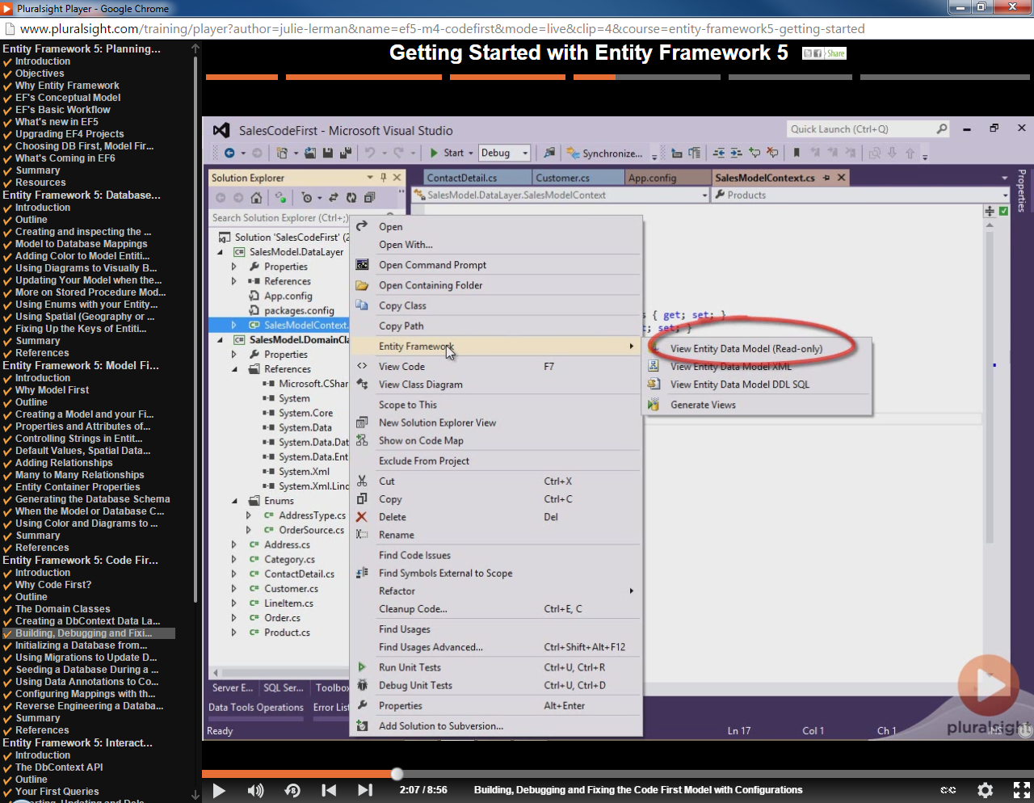

Scalar property – just represents a table column

DbSet – allows direct querying, if you don’t need to direct query an entity, no need for a DbSet.

Within Model First – edmx file contains mappings, and schemas.

With Code First – inheritance of DbContext managest mappings/schemas on the fly.

Code First – app.config holds db connection information.

Package Manager console -> enable-migrations

Annotations

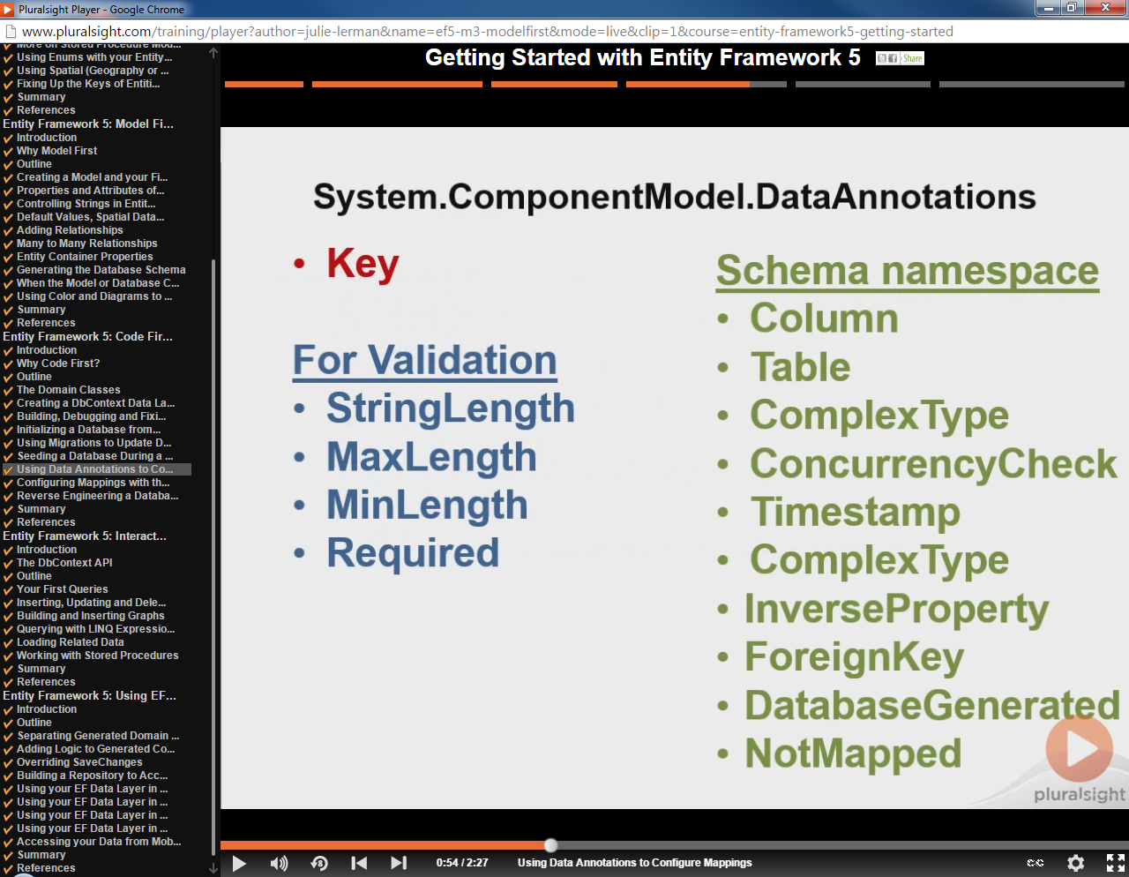

Database Initialization:

Connection String:

– find it (normal .NET application find methods)

Might be in app.config?

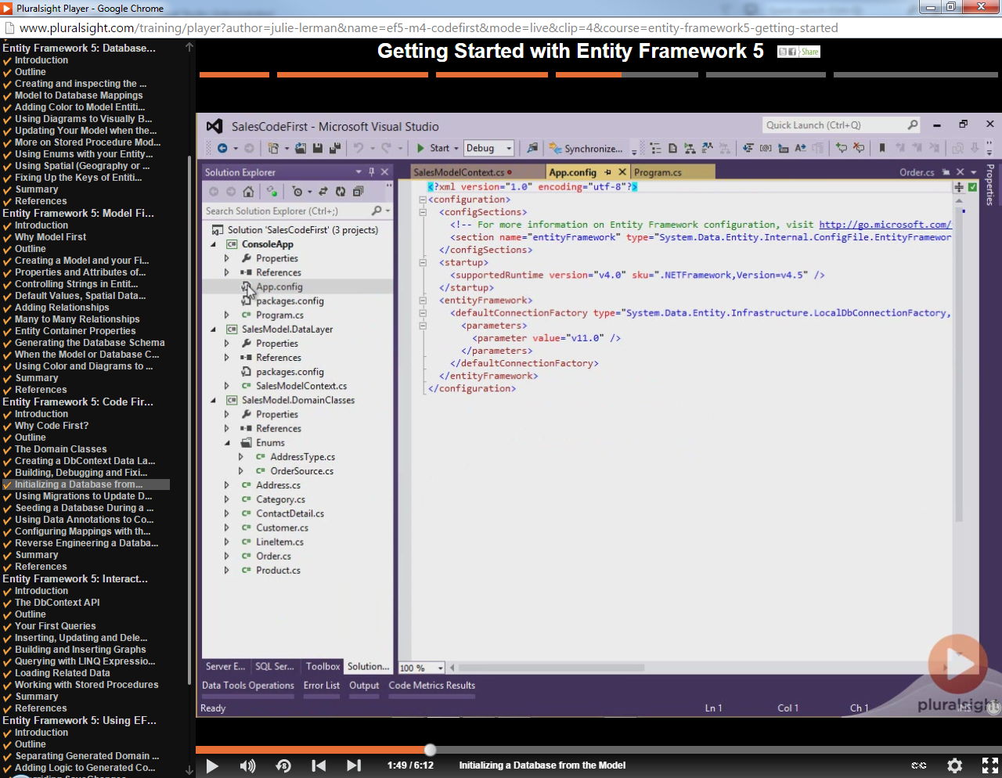

Defaults depend on provider being used. SQL Server uses local SQL Server Express.

Database Name:

Place name of database in context class constructor:

public partial class MoneyData : DbContext

{

public MoneyData()

: base("name=MoneyData")

{

}

}

Migrations

Must have configuration class(es) that derive from DbMigrationConfiguration

Auto Migration:

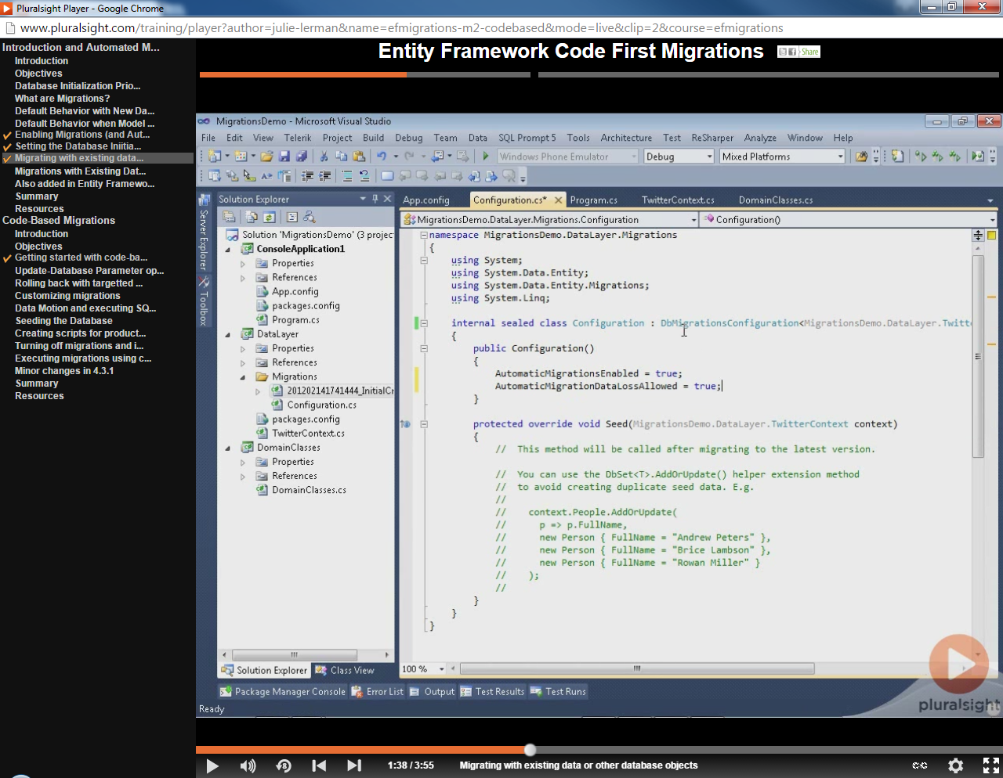

Use class that derives from DbMigration to customize migrations.

Initialization:

Code startup, can set the database initializer (Database.SetInitializer). Can also do in app.config, configSections, section.

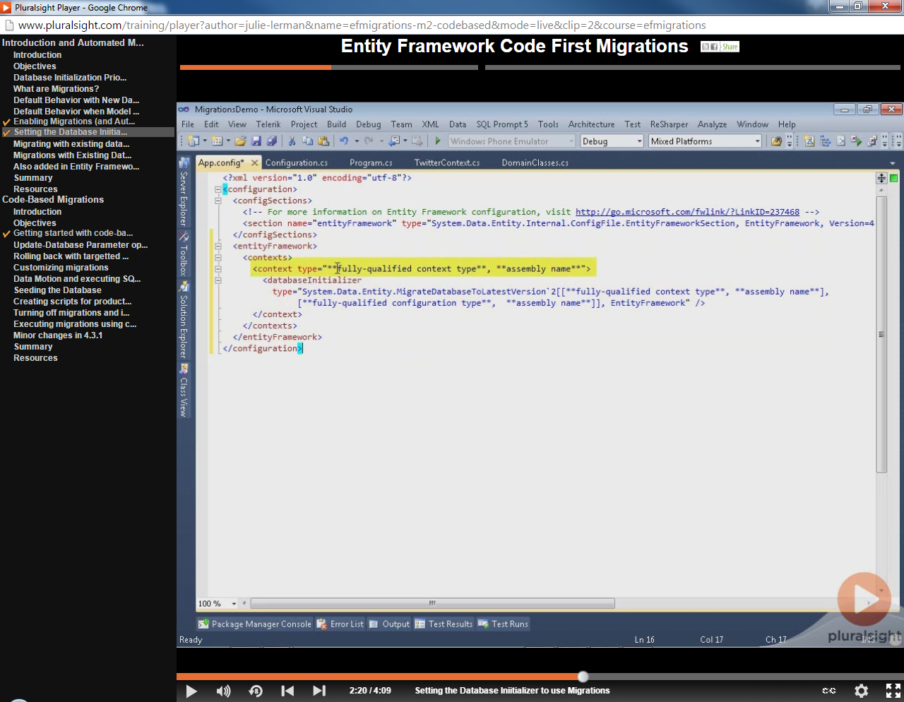

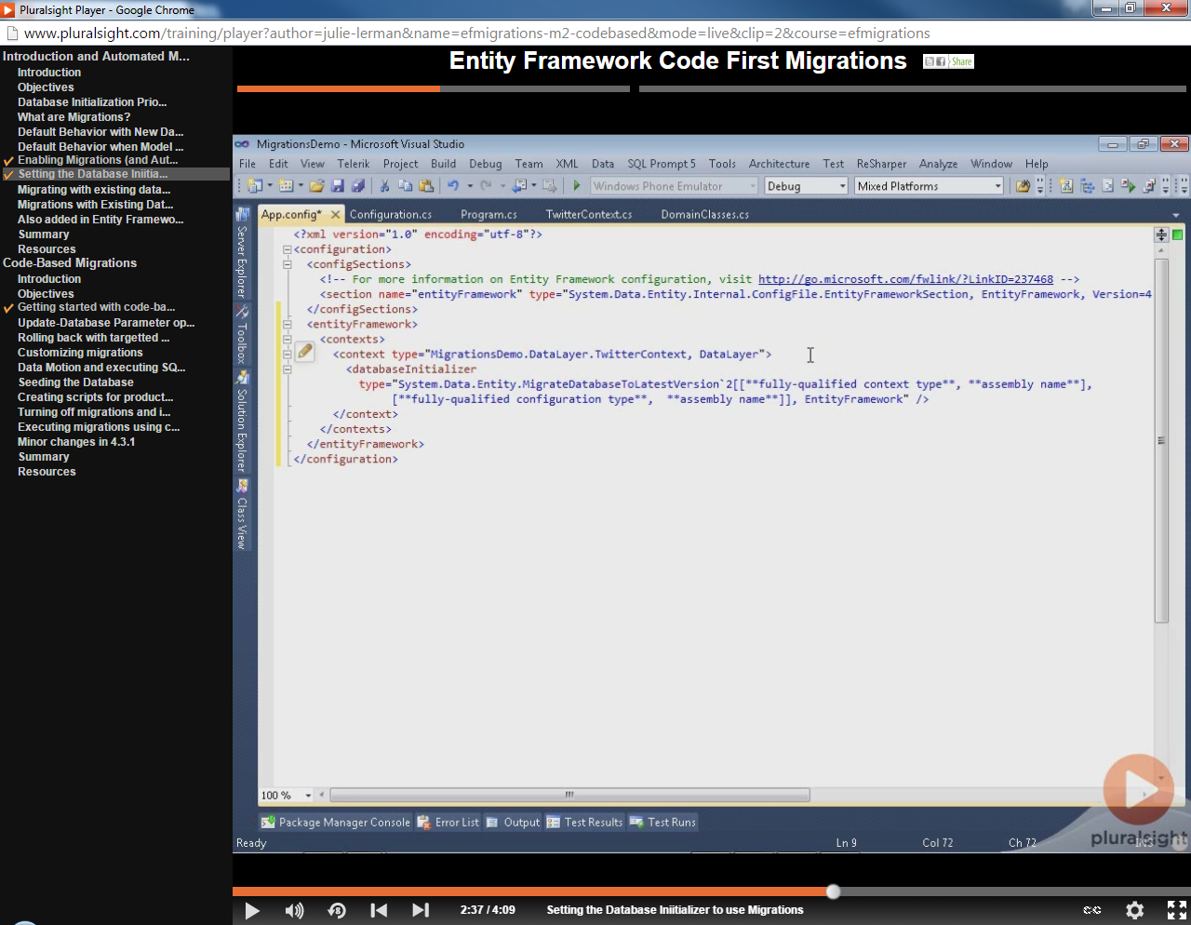

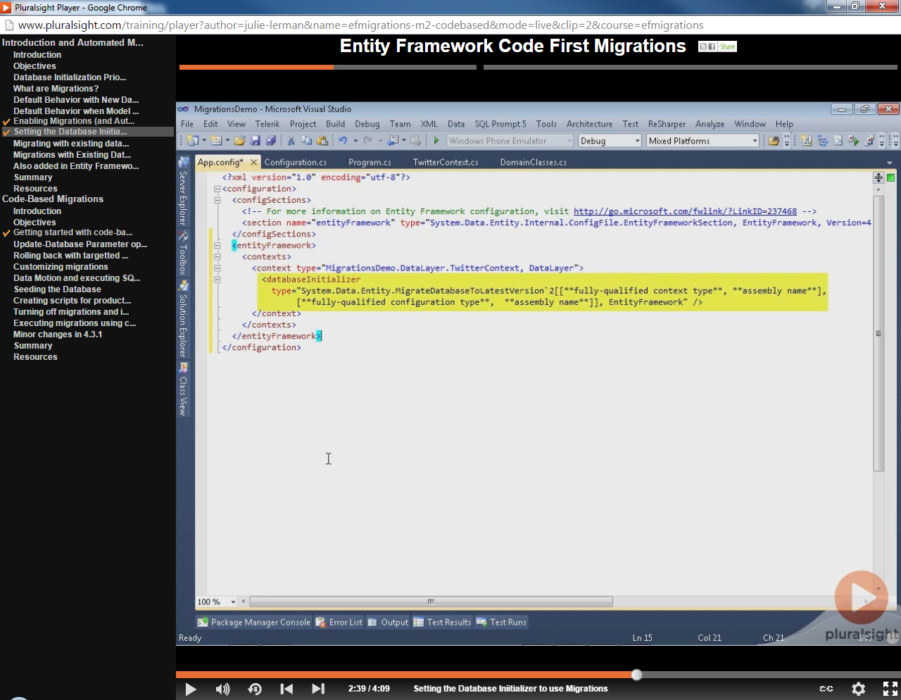

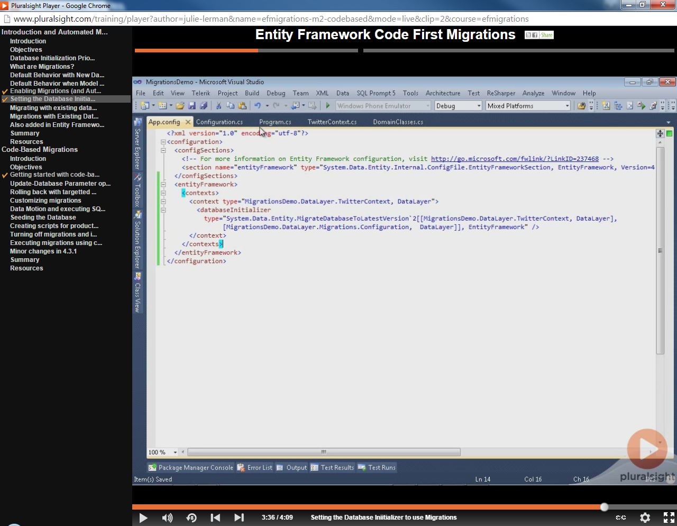

Code Based Migrations:

Each migration stored in project.

Turn off automatic migrations:

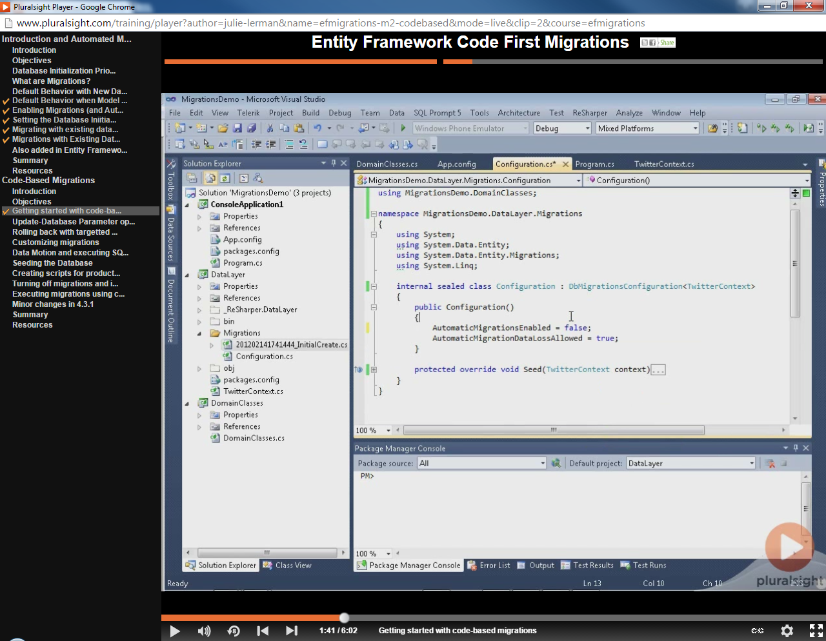

To generate the migration file:

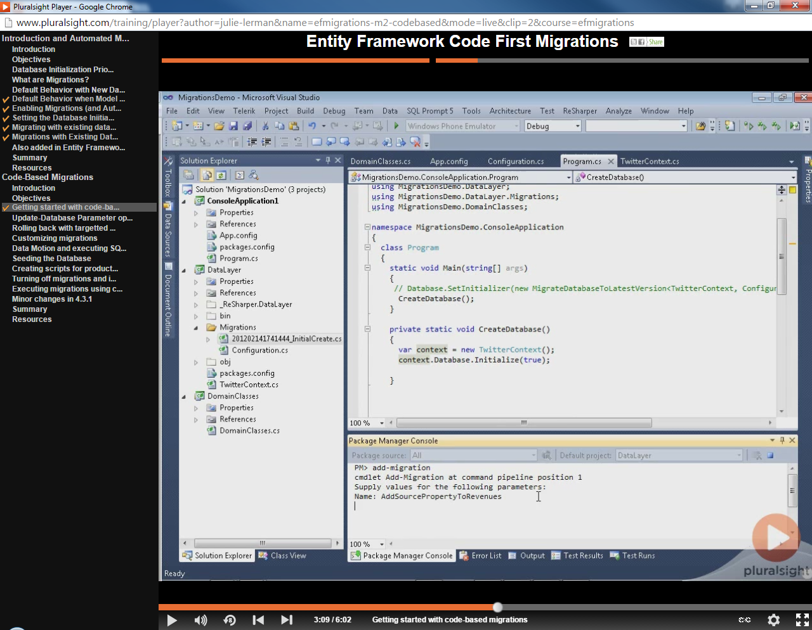

Creates migration file:

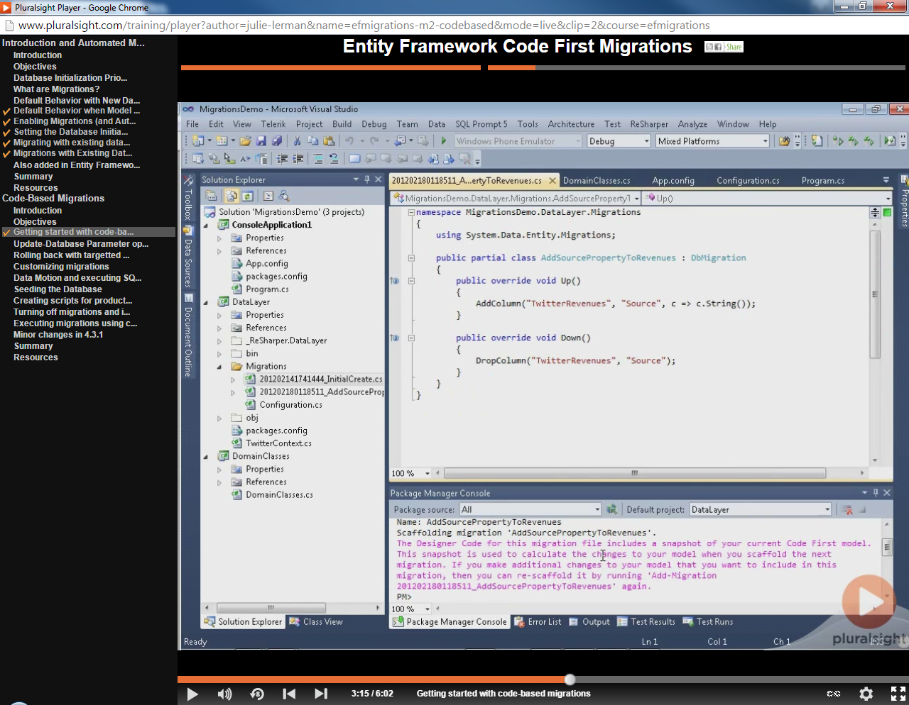

Apply migration to Database:

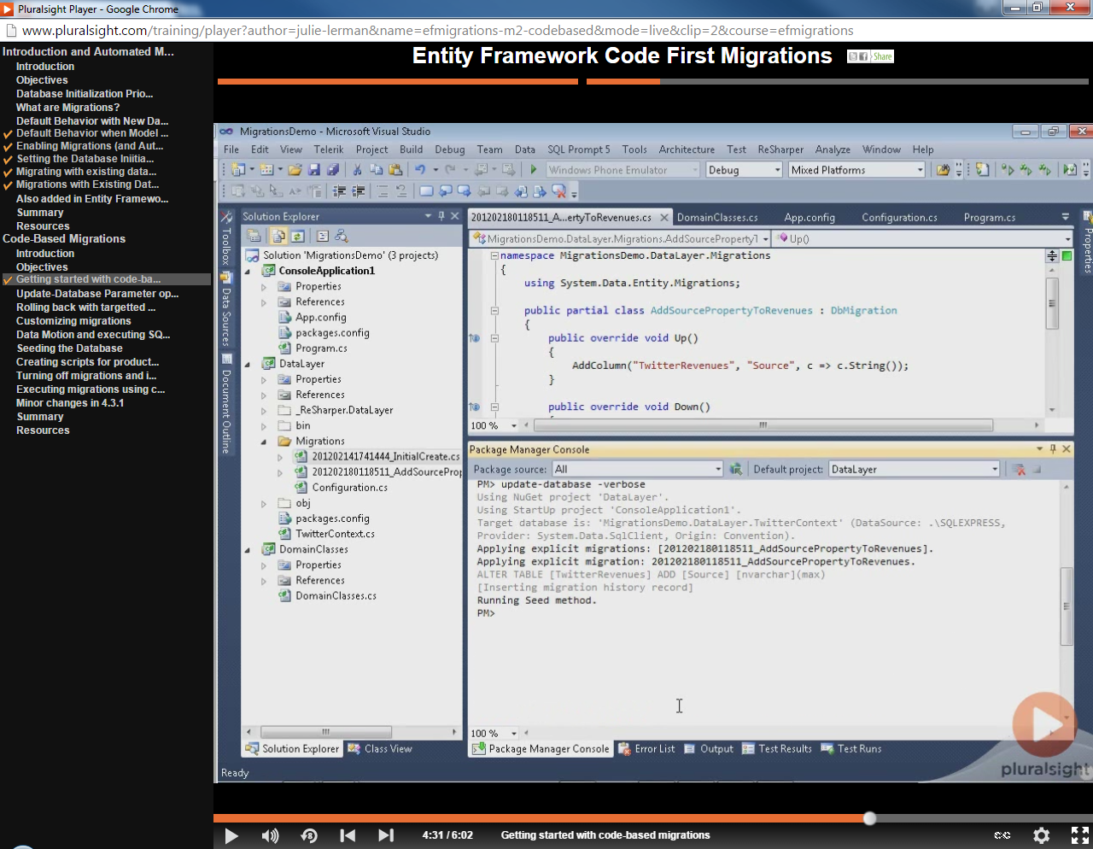

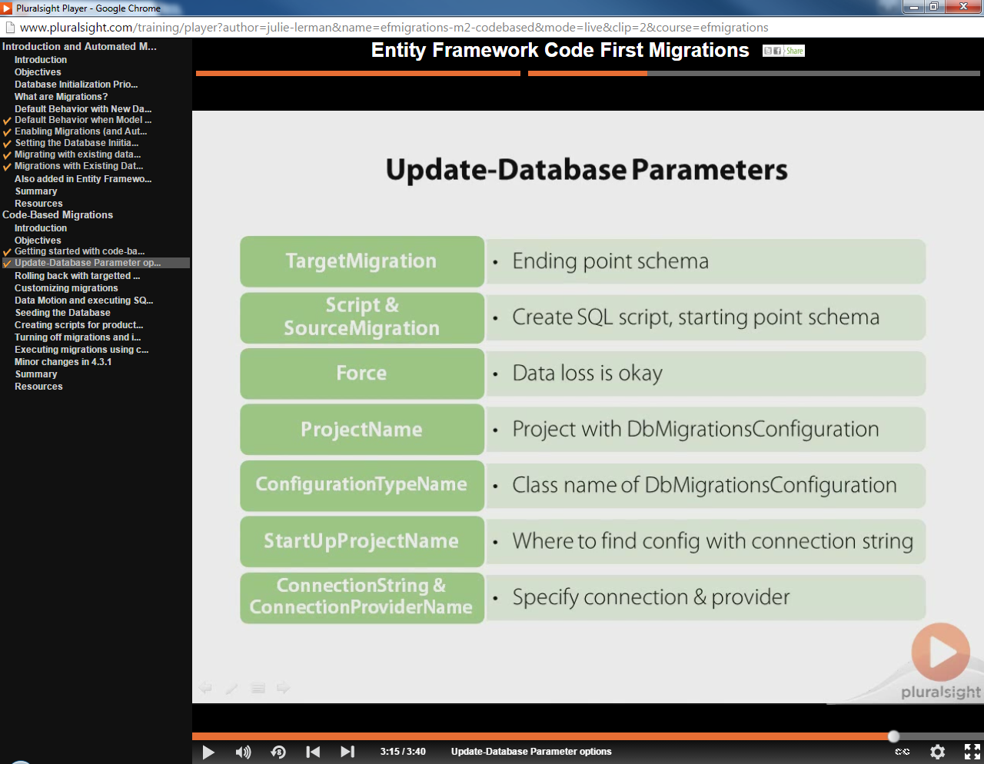

Detailed Help: PM> get-help update-database –detailed

**BE CAREFUL ON ROLLBACKS! Rollbacks to previous migration does not change the code.**

Customizing Migrations:

Derive class from DbMigration.

Can run SQL directly in the migration class:

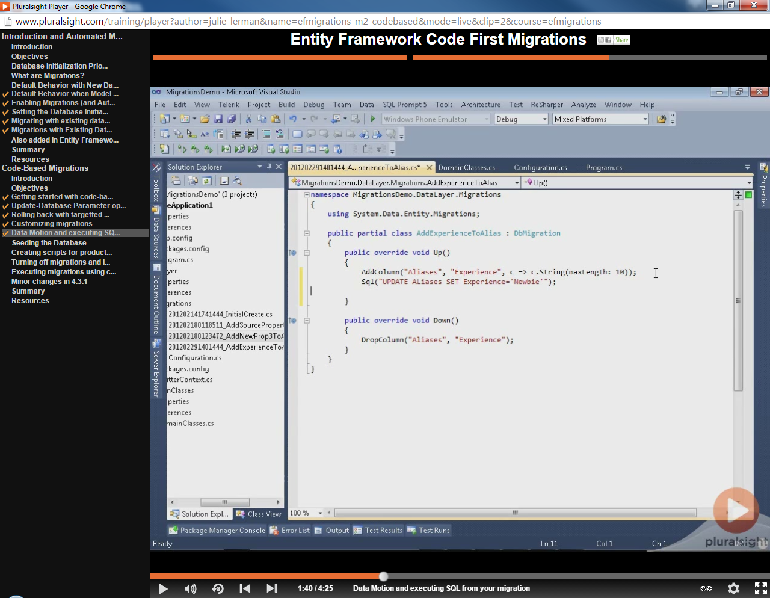

Running migration and return only a script:

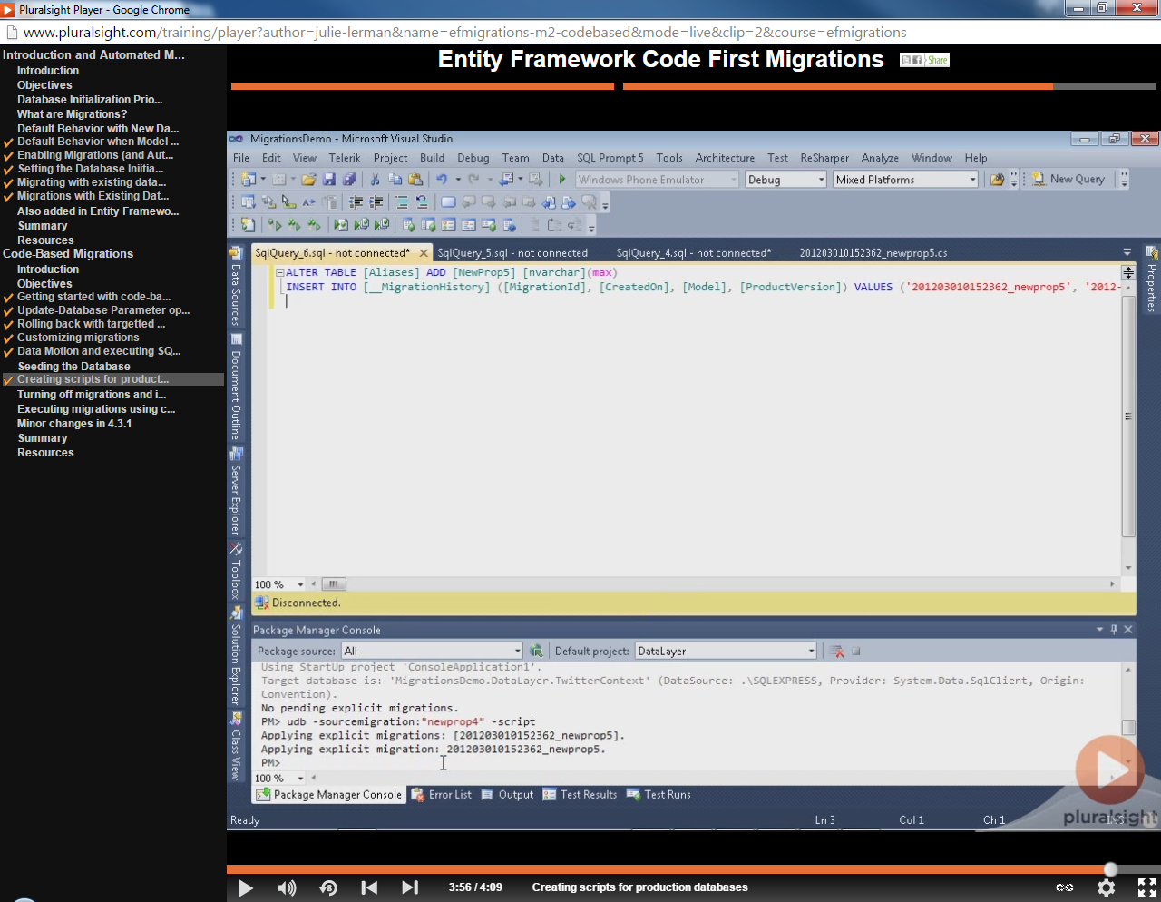

-sourcemigration parameter allows you to say from when you would like to create the script.

Shutting off migrations for production, turning on for development:

In app.config, set disableDatabaseInitialization to true. Set to false in dev environment.

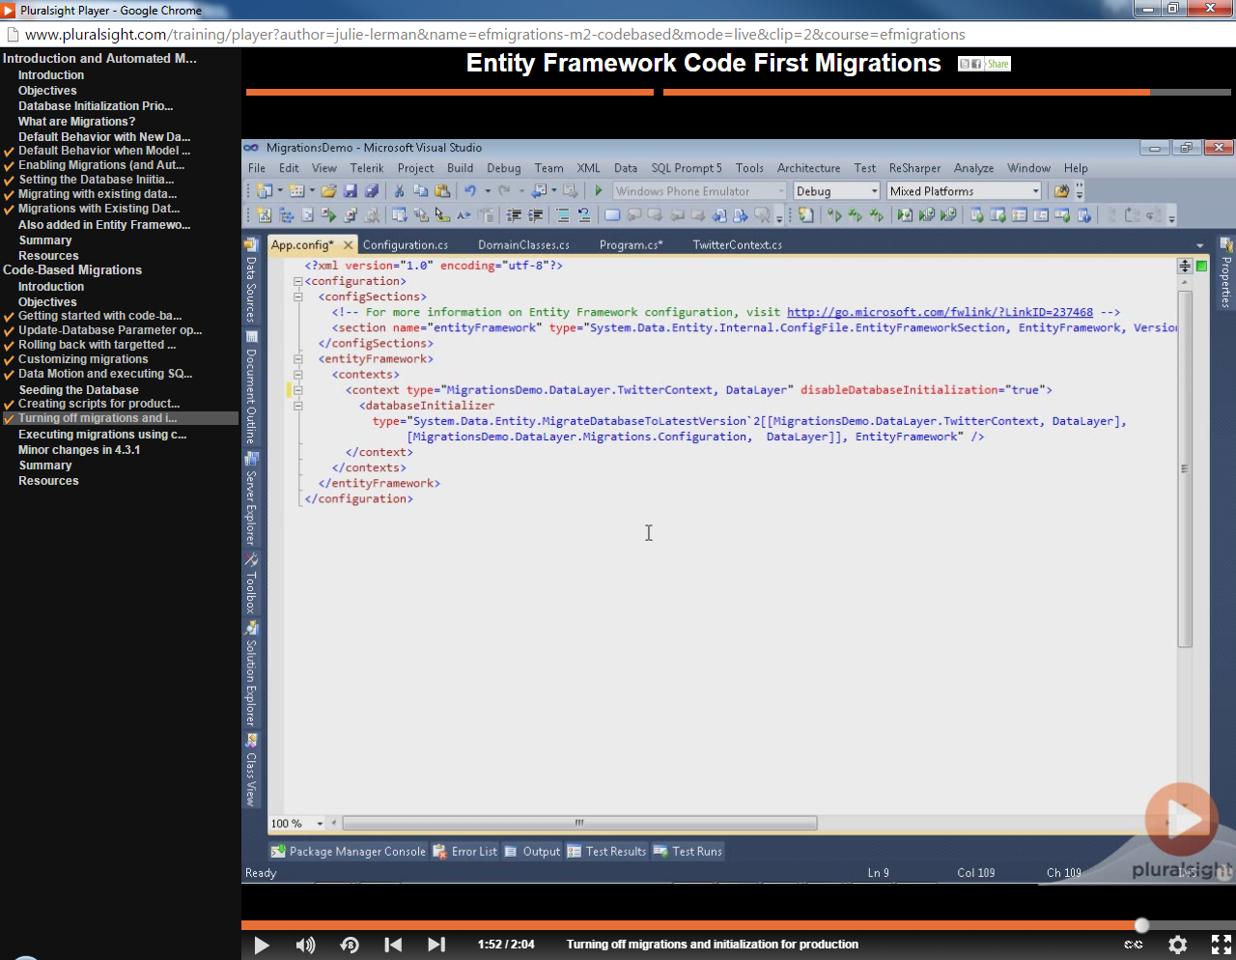

Running the migrations via code:

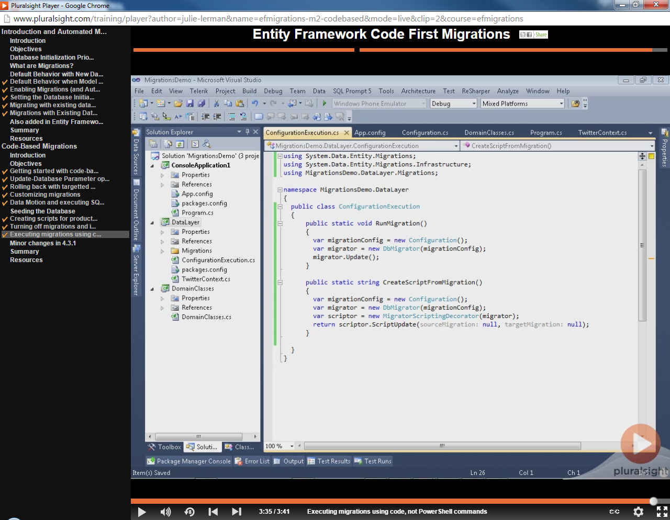

Lazy Loading:

Mark navigation property as virtual.

To manually force the load of the virtual field, in query:

var withAllProperties = db.Entity.Include(“virtual property name”)…

Complex Types:

public class Person

{

public int PersonID { get; set; }

//remaining Properties ...

public PersonAttributesType PersonAttributes { get; set; }

}

public class PersonAttributesType

{

public bool Attribute1 { get; set; }

public bool Attribute2 { get; set; }

public bool Attribute3 { get; set; }

}

* This situation will create a Person table, with a field for each Person property, as well as a field for each property of the complex type PersonAttributes:
  + - Person.PersonID
    - Person.PersonAttributes_Attribute1
    - Person.PersonAttributes_Attribute2
    - Person.PersonAttributes_Attribute3

If there were a property in the PersonAttributesType that could be interpreted as an entity key, ie, adding a property such as PersonAttributeId, EF would see this as an actual entity, and create a separate table for it and would leave no relationship/population of Person.PersonAttributes, since PersonAttributeId would not map to Person.PersonID.

Why it God’s name anyone would want to do this is beyond me!!!!

InverseProperty

InverseProperty is used when you have multiple relationships between classes. In the Enrollment class, you may want to keep track of who enrolled a Current Course and Previous Course. Let’s add two navigation properties for the Enrollment class.

public class Enrollment {

public int EnrollmentID { get; set; }

public int CourseID { get; set; }

public int StudentID { get; set; }

public Grade? Grade { get; set; }

public virtual Course CurrCourse { get; set; }

public virtual Course PrevCourse { get; set; }

public virtual Student Student { get; set; }

}

Similarly, you’ll also need to add in the Course class referenced by these properties. The Course class has navigation properties back to the Enrollment class, which contains all the current and previous enrollments.

public class Course {

public int CourseID { get; set; }

public string Title { get; set; }

[Index]

public int Credits { get; set; }

public virtual ICollection<Enrollment> CurrEnrollments { get; set; }

public virtual ICollection<Enrollment> PrevEnrollments { get; set; }

}

Code First creates {Class Name}_{Primary Key} foreign key column, if the foreign key property is not included in a particular class as shown in the above classes. When the database is generated, you will see the following foreign keys.

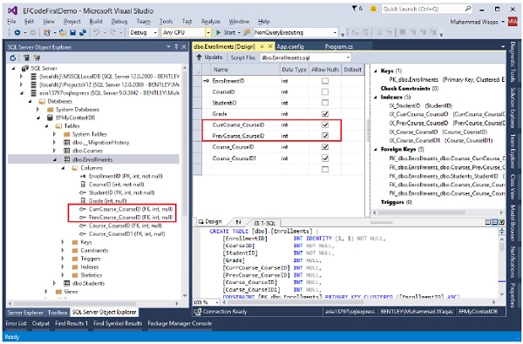

As you can see that Code first is not able to match up the properties in the two classes on its own. The database table for Enrollments should have one foreign key for the CurrCourse and one for the PrevCourse, but Code First will create four foreign key properties, i.e.

* CurrCourse _CourseID
* PrevCourse _CourseID
* Course_CourseID, and
* Course_CourseID1

To fix these problems, you can use the InverseProperty annotation to specify the alignment of the properties.

public class Course {

public int CourseID { get; set; }

public string Title { get; set; }

[Index]

public int Credits { get; set; }

[InverseProperty("CurrCourse")]

public virtual ICollection<Enrollment> CurrEnrollments { get; set; }

[InverseProperty("PrevCourse")]

public virtual ICollection<Enrollment> PrevEnrollments { get; set; }

}

As you can see the InverseProperty attribute is applied in the above Course class by specifying which reference property of Enrollment class it belongs to. Now, Code First will generate a database and create only two foreign key columns in Enrollments table as shown in the following image.

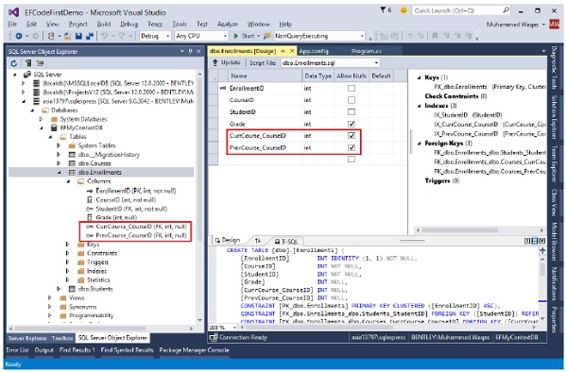

We recommend that you execute the above example in a step-by-step manner for better understanding.